BUCKET TOURNAMENT

Sunday 12th November 2017

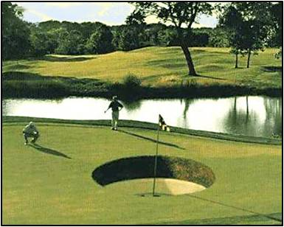

Shot gun start - 10am
3 Person Ambrose

Men off Whites & Women off Yellows

$25 club members
$30 affiliate non members
$35 non affiliates

Register your Entry by Email at wainuigolf@xtra.co.nz.
Or call one of our office members on 564 7746
LIMITED TO 36 TEAMS

